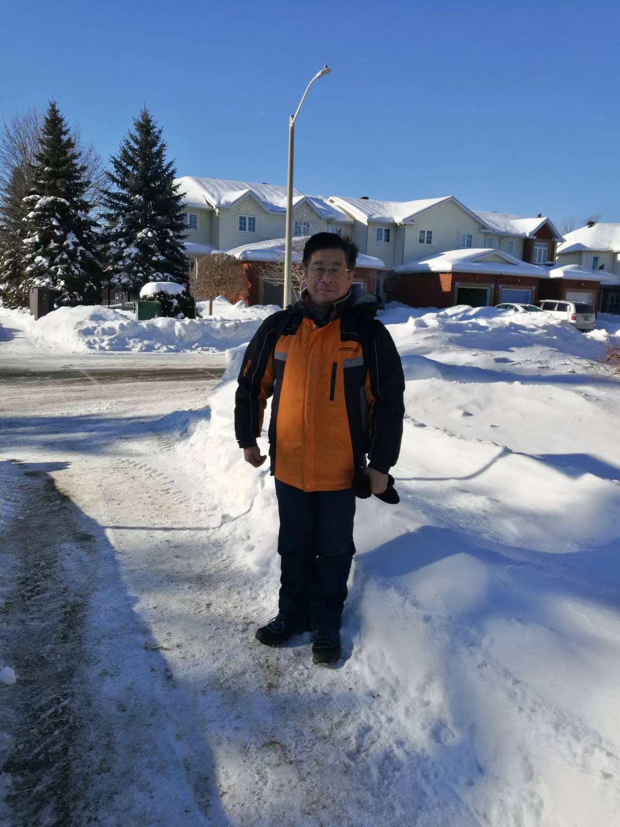
DeGui Sun, Mobile：13364485972, Email：sundg@cust.edu.cn
2018-Present：He has reached much more highly-valuable, and significant achievements in “The transmission, transportation, optical field modulation and manipulation, advanced electrooptic functional materials and devices, electro-optic sensors, etc.”：27 papers in SCI source indexed journals、6 China invention patents awarded、3 keynote/invited talks；has raised 23 post-graduates: 5 Ph.D degree and 18 Master degree graduates earned degrees；is currently raising 12 post-graduates: 2 Ph.D degree and 10 Master degree graduates. Since 2013, totally reviewed more than 30 manuscripts for more than 15 journals.
EDUCATION
Post-Doc Fellow, in Integrated Photonics and Optoelectronics: 1994-1997
University/Country: J.J. Pickle Microelectronics Research Center, University of Texas at Austin, USA
Research area: Polymer waveguide modulators, and LiNbO₃ crystal beam guiding

Philosophy Doctor of Electrical Engineering, in Applied Physics/Optoelectronics: 1989-1993
University/Country: Graduate University of the Chinese Academy of Sciences (CAS), China
Dissertation Title: Optical Butterfly Interconnects and Applications in Optical Computing

Master of Science and Engineering, Optics & Photonics Technology and Applications: 1985-1988
University/Country: Graduate University of the Chinese Academy of Sciences (CAS), China
Thesis Title: Design Methodology and Applications of Optical Devices of Dielectric Thin Films

Bachelor of Science in Optical Science and Engineering: 1981-1985
University/Country: Harbin Institute of Technology, China
Thesis Title: Design, Fabrication and Measurement for Big Lens

RESEARCH INTERESTS
BaTiO₃ Crystal Thin-Film Properties and Electro-Optic Functional Devics
(1) On Si platform, the electro-optic (EO) and elasto-optic characteristics of BaTiO₃ crystal thin-film, the new functional devices, and the special applications, improvements of these characteristics via both chemical-physical methods.
(2) Ferroelectric characteristics of BaTiO₃ crystal thin-film waveguide: high-order nonlinear EO modulation theory, physical property of crystal domains for realizing the high bandwidth (40110GHz) EO modulators.
(3) Variable wavefronts of orbital angular momentum (OAM) beams created by optical phase-polarization modulation of BaTiO₃ crystal thin-film waveguide: the controllable four-dimensional (4-D) vortex mode distribution and encoding.
(4) High-order multi-dimensional EO modulation schemes of BaTiO₃ crystal thin-film waveguide and applications for fiber-optic (FO) telecommunications and free-space optical (FSO) communications.
(5) High-sensitivity EO sensors of both the electric-fields and the ultraweak pressure with BaTiO₃ crystal film waveguides under new EO modulation theory and surface plasmonic cavity.
(6) Optical communication-sensing-integration of BaTiO₃ crystal thin-film waveguide and photonic integrated circuit (PIC) functional systems.
Silicon Waveguide Technology and Photonic Integrated Circuit (PIC) Devices: Fabrications and Applications in Optical Communication and Optical Circuit Switching (OCS) systems:
(1) BTO/Silicon hybrid waveguide high-speed switches via quantum mode-matching theory, polarization-dependent directional couplers, and Goos-Hanchän (GH) spatial shift.
(2) High-speed high port account optical matrix switches (OMS) and wavelength selective switches (WSS) with SOI waveguide-based PIC technology and Goos-Hanchän (GH) spatial shift.
(3) High precision measurements and standards of the 3-D sidewall roughness (SWR) distribution of the SOI, Si₃N₄ (SiN) and micro-/nanoscale waveguides with the CLSM and the SWR-improved Payne–Lacey (P-L) three-dimensional (3-D) formalism and Hörmann’s 3-D perturbation model for calculating the optical propagation loss (OPL).
(4) Correlativity among the fabrication tolerance, the measurement error, and the specifications of functional devices with metrology of the CLSM and the new roughness theory.
(5) Complementary etching-oxidation of silicon (CEOS) fabrication methodology for Si-based (SOI, SiN) waveguide chips – Manufacture, testing, packaging and applications of silicon PIC chips.

EMPLOYMENT EXPERIENCE, POSITIONS and ACHIEVEMENTS
2017.1-present: Part-time Professor, School of Physics, Changchun University of Science and Technology, China.
2026.1-present: Part-time Professor, School of Electronic Information and Engineering, Nanjing University of Aeronautics and Astronautics, China
(1) R&D of silicon PIC components: new principles, fabrication, measurement metrology, and applications.
(2) Research of ferroelectric & EO properties of BaTiO₃ crystal thin-film and high bandwidth modulators.
(3) Teaching Advanced Guided Photonics, Optoelectronic Information Science and Engineering in English.
◻Main Achievements in BaTiO₃ crystal film waveguide:
- Demonstration for the variable wavefronts of orbital angular momentum (OAM) of BaTiO₃ crystal film with the complementary modulations of polarization and optical phase.
- Demonstration for the matching theory between microwave and light-wave standard of BaTiO₃ crystal thin-film waveguide high-speed intensity EO modulator.
- Proposed and demonstrated a new equation of the bit-energy definition of high-speed MZI type intensity modulator in theory and experiment.
- In theory/experiment compressed the modulation output signal width of BaTiO₃ crystal thin-film waveguide high-speed intensity EO modulator.
- Successful measurements of the off-axis EO tensor coefficient and the birefringence of BaTiO₃ crystal film with the complementary modulations of polarization and optical phase.
- Built a theoretical model for defining the dependences of the EO coefficient on both the temperature and the initial polarization fraction with the energy conservation in crystal domains.
◻ Main Achievements in Silicon PIC circuits and devices:
- Fabricated a vertical metasurface structure into silicon waveguide and demonstrated its enhancement role in manipulating the GH shifts.
- In theory/experiment compared the two typical theoretical models for calculating the OPL of silicon waveguides.
- Optimized the fabrication tolerance of SiN waveguide 40-channel arrayed waveguide (AWG) for the polarization mode dispersion (PMD).
- Demonstration for the conversion of SOI-waveguide to the Silica-on-Silicon (SOS) waveguide via complementary etching-oxidation of silicon (CEOS) fabrication method and P ion doping.
- Successful measurements of the sidewall roughness (SWR) of SOI and SiO₂ waveguides with the CLSM metrology and defined a 3-D root-mean-square (rms) roughness standard.
- Successful measurements of the sidewall angle (SWA) of SOI and SiO₂ waveguides with the CLSM metrology and proposed a compensation standard of an intrinsic error.
- Modified the modern Payne-Lacey (P-L) model of defining the relation between the optical propagation loss coefficient and the SWR of a waveguide by introducing the 3-D SWR.
- Demonstrated an intra-guide mode conversion scheme by changing an SOI waveguide to a SiO₂ waveguide to reduce chip-fiber butt-coupling loss with a local oxidation of silicon (LOCOS).
- Derived an exclusive thermodynamic theoretical model of the Henry’s law constant in the hyperthermal oxidation of silicon to perform the broad simulations of hyperthermal oxidation.
2013-2016: School of Science at CUST/China (part-time) and University of Ottawa (uOttawa)/Canada (part-time).
JDS Uniphase Corporation, Nepean, Ontario, Canada: (part time).
Systematic measurements of the newly developed 40-ch Array Waveguide Grating Products.
2008-2010: Research Scientist and Project Leader in Optoelectronic Components at CRPuO/Canada
Achievements:
- Obtained a proposal “SOI waveguide High-Speed Micro-Size Optical Switch” from OCE, $150,000 CAD, I was the proponent and Trevor Hall was the applicant. (finished)
- Obtained a proposal fund from National Research Council of Canada: Idea to Innovation (i2i) with the same proposal title: “SOI waveguide High-Speed Micro-Size Optical Switch”, I was the proponent of this project and Prof. Trevor Hall was the applicant. (finished)
- Found the intrinsic limitations of MZI type EO modulated devices based on SOI waveguides and the refractive index modulation of silicon free-carrier dispersion (FCD) effect. (finished)
2003-2006, Leader Professor of 100-Talent Plan Project of Chinese Academy of Sciences at Changchun Institute of Optics, Fine Mechanics and Physics (CIOMP), Changchun, JL, China
Research on the Advanced Optical Communication Components. Main achievements:
- Obtained a proposal entitled by “Research on the Advanced Optical Communications” funded by Chinese Academy of Sciences: 100-Talent Plan fund. (finished)
- Obtained a proposal “A wavelength selective switch with MEMS and micro-optics” from Natural Science Foundation of China (NSFC): regular fund. (finished)
- Device chip prototypes of MZI type optical switch and nonblocking matrix switches silica-on-silicon (SOS) from 22 scale to 1616 scale. (finished)
2002-2003, Leader Research Associate at Northwestern University, Evanston, IL USA
Research on the self-assembly polymer waveguide EO modulator and the properties of BaTiO₃ crystal film.
Main achievements:
- Built a theoretical model of the nonlinear EO modulation process of BaTiO₃ crystal waveguides.
- Optimized the device construction the self-assembly polymer waveguide EO modulator.
1999-2002, Product Development Engineer and design authority in a company – Nu-Wave Photonics (later changed to Zenastra Photonics), Ottawa, ON Canada
Responsible for designs of products on the silica waveguide platform.

2. PUBLICATIONS: Since 2011 to present
2.1 Since 2018:
- J. Li, D. G. Sun*, Y. Li, M. Luo, N. Sun, and D. Wu*, "Variable wavefronts of light-beam caused by phase-polarization electro-optic modulation of BaTiO₃ crystal thin-film waveguide," Appl. Phys. Lett. 128(22), 224101 (2026). [DOI: 10.1063/5.0321837 ]
- M. Bi, D. G. Sun*, Y. Lin, Y. Li, P. Yu, Z. Yu, Y. Sun, S. Guo, L. Guo, and M. Yu*, "Two theoretical model comparison for calculating the optical propagation loss of silicon-on-insulator waveguides," Coatings 16(3), 323_1-14 (2026). [DOI:10.3390/coatings16030323]
- J. Zhang, D. G. Sun*, Z. Wang, Z. Wen, and K. P. Zhang, (Invited Paper) "Microwave characteristics and bandwidths of BaTiO₃ crystal film waveguide electro-optic modulator to match light-wave bandwidth," Physica Status Solidi (RRL) 20(1), e202500340 (2026). [DOI:10.1002/pssr.2025000340]
- Y. Sun, D. G. Sun*, Y. Li, Y. Lin*, C. Liu, Y. Zhu, M. Bi, Y. Xu, P. Yu, and T. Yu*, “Low-loss silica-SOI monolithically integrated single-mode waveguides via the fabrication of complementary etching-oxidation of silicon”, Opt. Mater. Exp. 16(2), 446-454 (2026). [DOI:10.1364/OME.585257]
- Z. Yu, D. G. Sun*, M. Bi, Y. Sun, and S. Guo, “Performance simulation and optimal design for silicon-nitride arrayed waveguide grating”, Coatings 16(1), 63_1-19 (2026).
[DOI: 10.3390/coatings16010063]
- N. Sun, D. G. Sun*, D. Wu, Y. Guo, Y. Fan, F. Zou, M. Pu, and X. Luo*, "Lowering the bit-energy of electrooptic intensity modulators via polarization-phase modulation in thin-film BaTiO₃ ferroelectric crystal waveguide," Las. & Photon. Rev. 18(3), 2300937 (2024). [DOI: 10.1002/lpor.202300937]
- Y. Zhang, D. G. Sun*, M. Yu, Y. Xu, and Z. Chen, "Active manipulation of Goos-Hänchen shifts of guided-wave via a metasurface of silicon-nanoscale semi-spheres on SOI waveguide," Opt. Exp. 32(11), 19999-20010(2024). [DOI: 10.1364/OE.5522948]10.1364/OE.522948
- N. Sun and D. G. Sun*, "Phase-polarization ensemble modulation effect of BaTiO₃ crystal film waveguide on MZI electrooptic intensity modulators," Appl. Opt. 61(8), 1851-1855 (2022).
- Y. Shi, W. Liu, S. Liu, T. Yang, Y. M. Dong, D. G. Sun*, and G. Y. Li, “Strong coupling between plasmonic surface lattice resonance and photonic microcavity modes”, Photonics 9(1), 84 (2022).
- Y. Shi, Y. M. Dong, D. G. Sun*, and G. Y. Li, “Significant near field enhancement over large volumes around metal nanorods via strong coupling of surface lattice resonances and Fabry-Pérot resonance”, Materials 15(1), 01523 (2022).
- Y. Shi, L. Xiong, Y. M. Dong, D. G. Sun*, and G. Y. Li, “Quality factor enhancement of plasmonic surface lattice resonance by using asymmetric period”, Chin. Phys. B 31(1), 014217 (2022).
- N. Sun, Y. Han, D. G. Sun*, et al., “Temperature and initial polarization dependences of the electrooptic coefficient of BaTiO₃ crystal film”, Opt. Mat. Exp. 11(8), 2730-2742 (2021).
- T. Yu and D. G. Sun*, “Thermodynamic insights into Henry’s constant in hyperthermal oxidation of silicon for fabricating optical waveguides”, Phys. Chem. Chem. Phys. 23(8), 17354-17364 (2021).
- N. Sun, D. G. Sun*, Y. Han, et al., “Methodological analysis for the electrooptic coefficient and birefringence of BaTiO₃ crystal films with complementary polarization modulations”, Meas. Sci. & Technol. 32(1), 015001 (2021).
- M. X. Luo, D. G. Sun*, and G. Y. Jin "An ultrahigh sensitivity three-dimensional electric-field sensor with barium titanate crystal waveguides," AIP Advances 12(5), 055317 (2022).
- Chen Z., Sun D. G.* et al., “Digital Thermo-optic Switch of SOI Waveguide Based on Goos-Hänchen Spatial Shift of Reflected Mode,” ACTA PHOTON. SIN., 50(4), 0423001 (2021).
- Wang B., Sun D. G.* et al., "Investigation for Relationship between Sidewall Roughness of SOI Waveguide and Loss of Guided-mode," ACTA PHOTON. SIN., 50(5), 0506005 (2021).
- Yu T., Sun D. G.* et al., “Precision Measurement and Theoretical Analysis of SOI Waveguide Transmission Loss and Butt-coupling Loss,” ACTA PHOTONICA SINICA, 50(7), 0713001 (2021).
- T. Yu, D. G. Sun* et al., “Intraguide mode conversion of silica-on-silicon transfer waveguides and SOI tapered structures for highly efficient chip-fiber butt coupling”, Appl. Opt. 59(36), 11253-11260 (2020).
- H. P. Shang, D. G. Sun*, et al., “Investigation for sidewall roughness caused optical scatting loss of silicon-on-insulator waveguides with confocal laser scanning microscopy”, coatings 10(3), 236 (2020).
- M. X. Luo, D. G. Sun*, N. Sun et al., “Strategic measurement for the axis orientation and electro-optic coefficient of BaTiO₃ crystal thin-film grown on MgO crystal with polarization modulations”, Opt. Lett. 44(17), 4215-4218(2019).
- Q. Y. Sun, D. G. Sun*, H. P. Shang, et al., “Study of birefringence and stress distribution of SiO₂ film optical waveguides on silicon wafer”, coatings 9(5), 316 (2019).
- D. G. Sun*, H. Shang, and H. Jiang “Effective metrology and standard of the surface roughness of micro/nanoscale waveguides with confocal laser scanning microscopy,” Opt. Lett. 44(4), 747-750 (2019).
- H. Shang, D. G. Sun* et al., “Analysis for the system errors in measuring sidewall angle of silica waveguide with confocal laser scanning microscope,” Meas. Sci. & Technol. 30(2), 025004 (2019).
- D. G. Sun*, Q. Sun et al., “Investigation for the structural stress of SiO₂ thin-films and its distribution on the large-wafer created by PECVD,” AIP Advances 8(8), 085217 (2018).
- Mengxi Luo and D. G. Sun*, “Ultra-efficient electro-optic modulation with a two-dimensional interaction regime,” J. Appl. Phys. 123(3), 034503 (2018).
- Y. Shi, H. Shang, and D. G. Sun*, “Investigation for all polarization conversions of the guided-modes in a bending waveguide,” Opt. Commun. 410(3), 211-214 (2018).

